**ASSIGNMENT – 3**

|  |  |
| --- | --- |
| Date | 15 October 2022 |
| Team ID | PNT2022TMID22388 |
| Student Name | Goutham G |
| Student Register Number | 113119UG03030 |

**1.Create a Bucket in IBM object storage.**

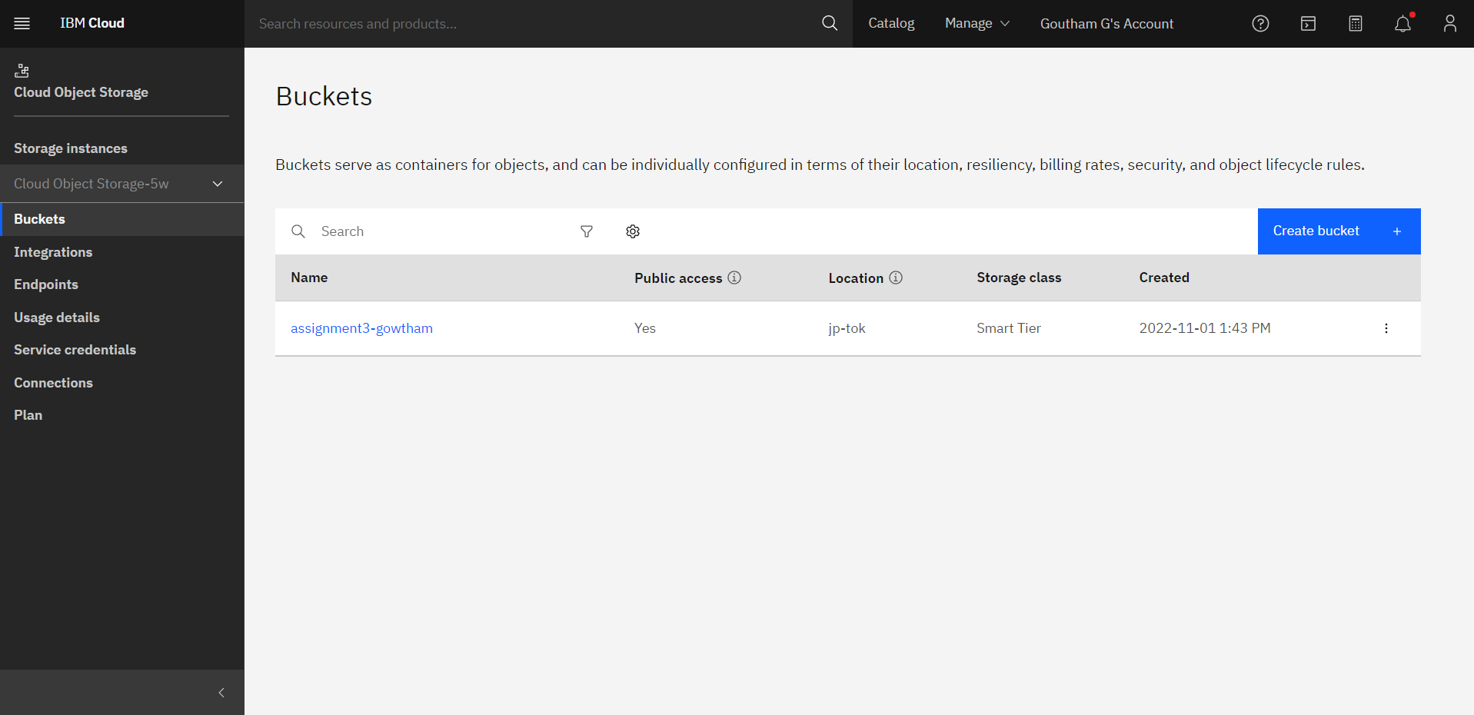**2.Upload 5 images to IBM Object Storage and make it public. Write html code to displaying all the 5 images.** 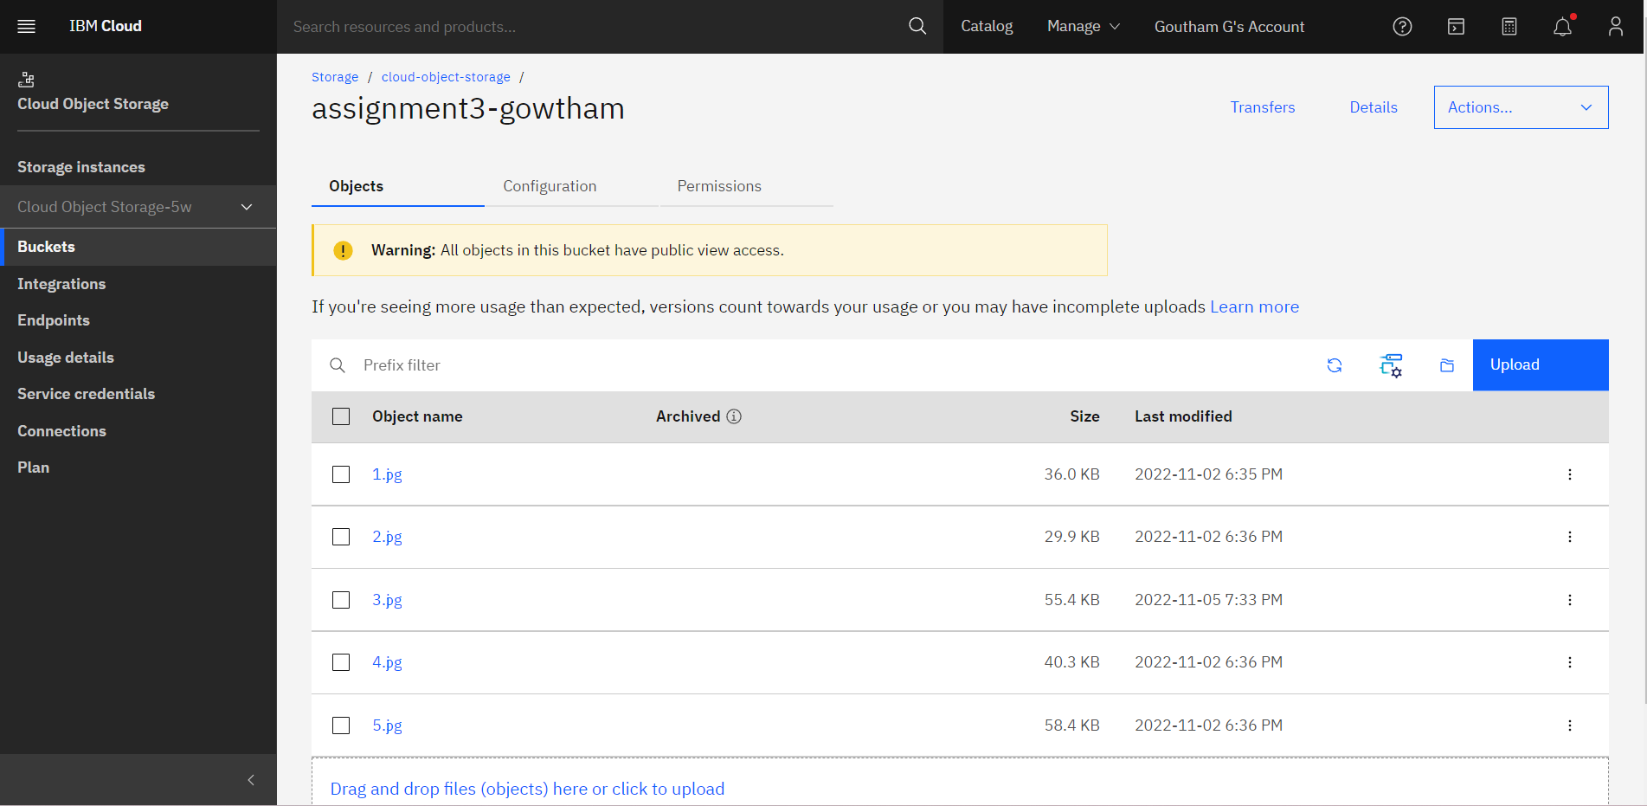

**HTML CODE:**

<!DOCTYPE html>

<html lang="en">

<head>

    <meta charset="UTF-8">

    <meta http-equiv="X-UA-Compatible" content="IE=edge">

    <meta name="viewport" content="width=device-width, initial-scale=1.0">

    {% block head %}

    <link href="https://assignment3-gowtham.s3.jp-tok.cloud-object-storage.appdomain.cloud/style.css" rel="stylesheet">

    <title>Assignment - 3</title>

    {% endblock %}

</head>

<body>

    {% block body %}

    <br><br><br><br>

    <h1>

        <center>Naruto Characters</center>

    </h1>

    <br><br><br><br>

    <center>

    <img src="https://assignment3-gowtham.s3.jp-tok.cloud-object-storage.appdomain.cloud/1.jpg" height="205px" weight="200px">&nbsp;

    <img src="https://assignment3-gowtham.s3.jp-tok.cloud-object-storage.appdomain.cloud/2.jpg" height="205px" weight="200px">&nbsp;

    <img src="https://assignment3-gowtham.s3.jp-tok.cloud-object-storage.appdomain.cloud/3.jpg" height="205px" weight="200px">&nbsp;

    <img src="https://assignment3-gowtham.s3.jp-tok.cloud-object-storage.appdomain.cloud/4.jpg" height="205px" weight="200px">&nbsp;

    <img src="https://assignment3-gowtham.s3.jp-tok.cloud-object-storage.appdomain.cloud/5.jpg" height="205px" weight="200px">&nbsp;

    </center>

    {% endblock %}

</body>

</html>

**3.Upload a CSS page to the object storage and use the same page in your HTML code.**

**CSS CODE:**

h1{

    font-size: 40px;

    color: blue;

}

img {

    border: 1px solid #ddd;

    border-radius: 4px;

    padding: 5px;

    width: 350px;

  }

**WEBSITE:**

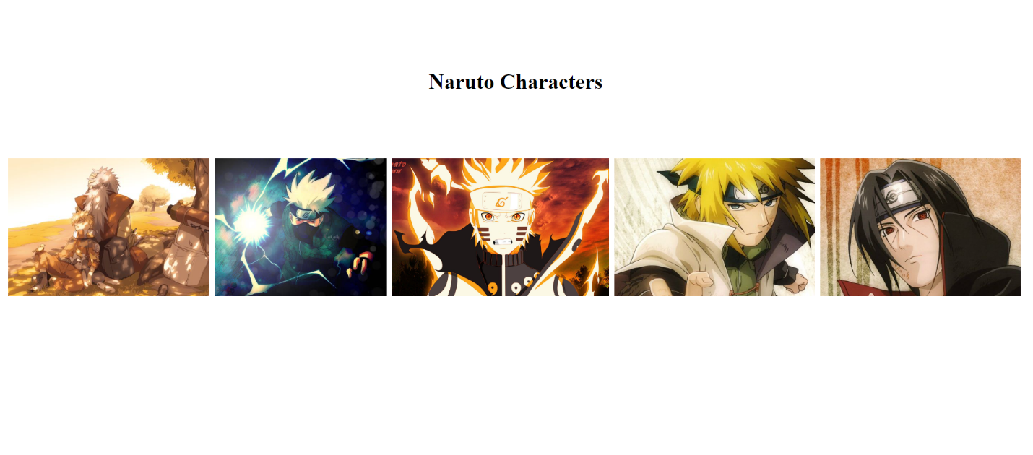

**4.Design a chatbot using IBM Watson assistant for hospital.**

**Ex: User comes with query to know the branches for that hospital in your city. Submit the web URL of that chat bot as an assignment.**

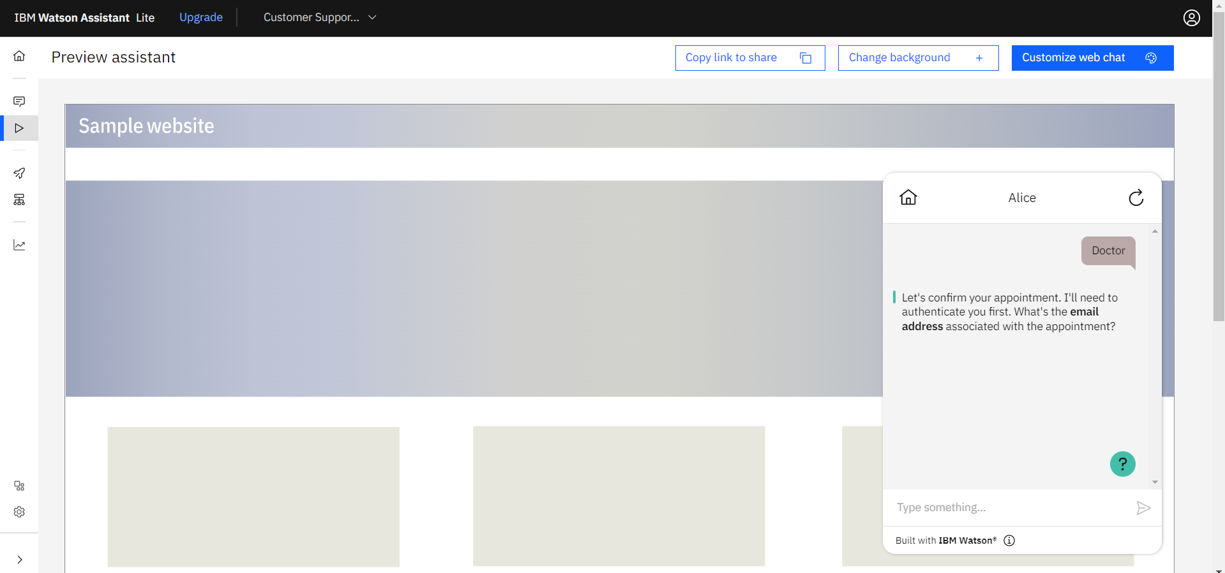

**5.Create Watson assistant service with 10 steps and use 3 conditions in it. Load that script in HTML page**

**IBM WATSON HEALTHCARE ASSISTANT**



